CTSE Lab Sheet 5 Answers
IT22049872

Github Link : https://github.com/chathuwa-whiz/microservices-lab.git

API testing evidence

GET
http://localhost:8080/items
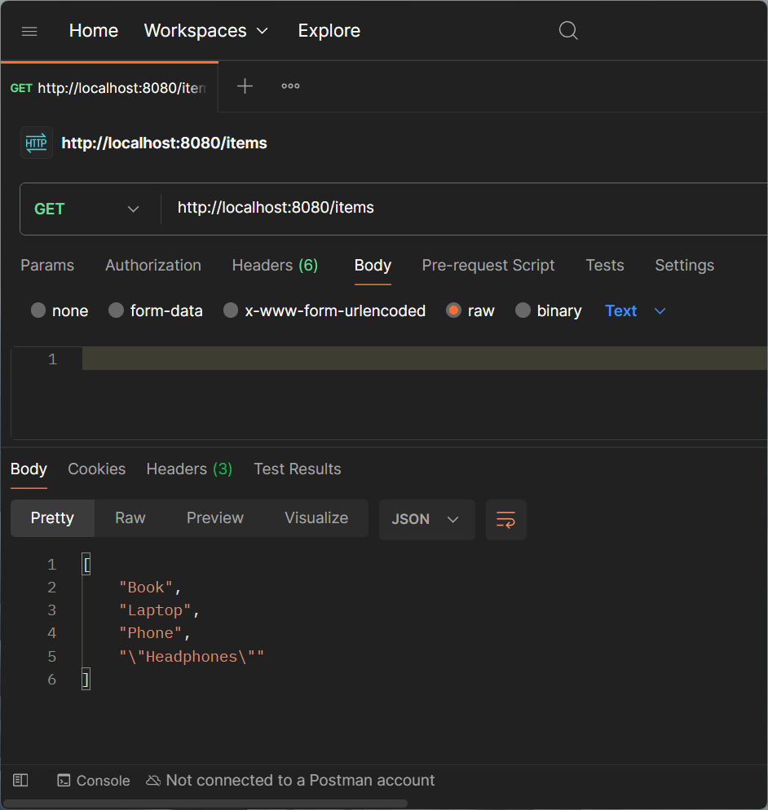
POST
http://localhost:8080/items
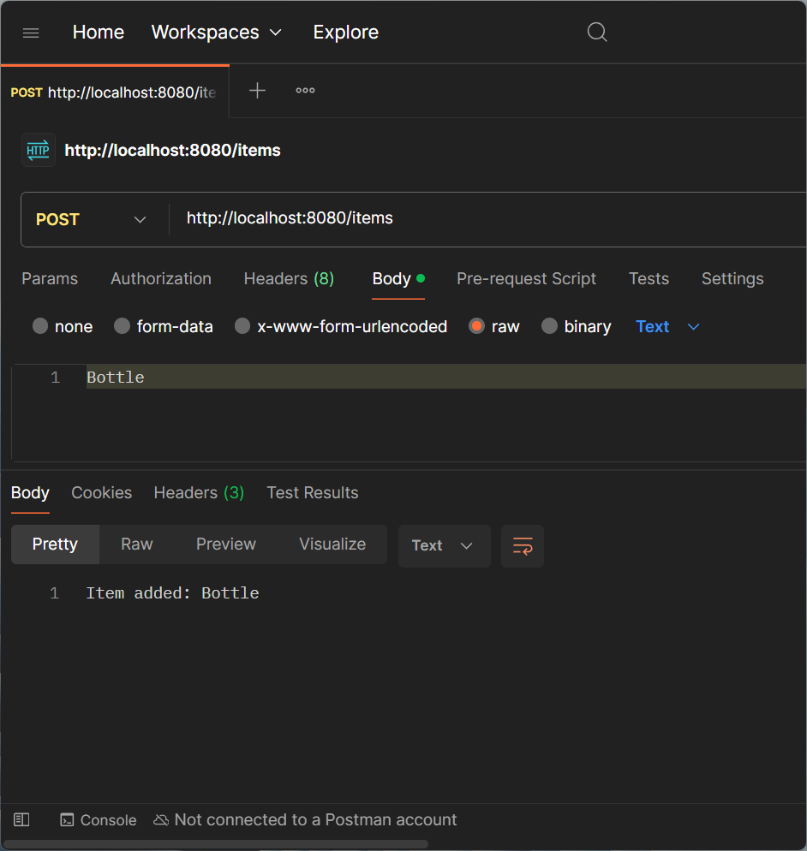

GET
http://localhost:8080/items/0
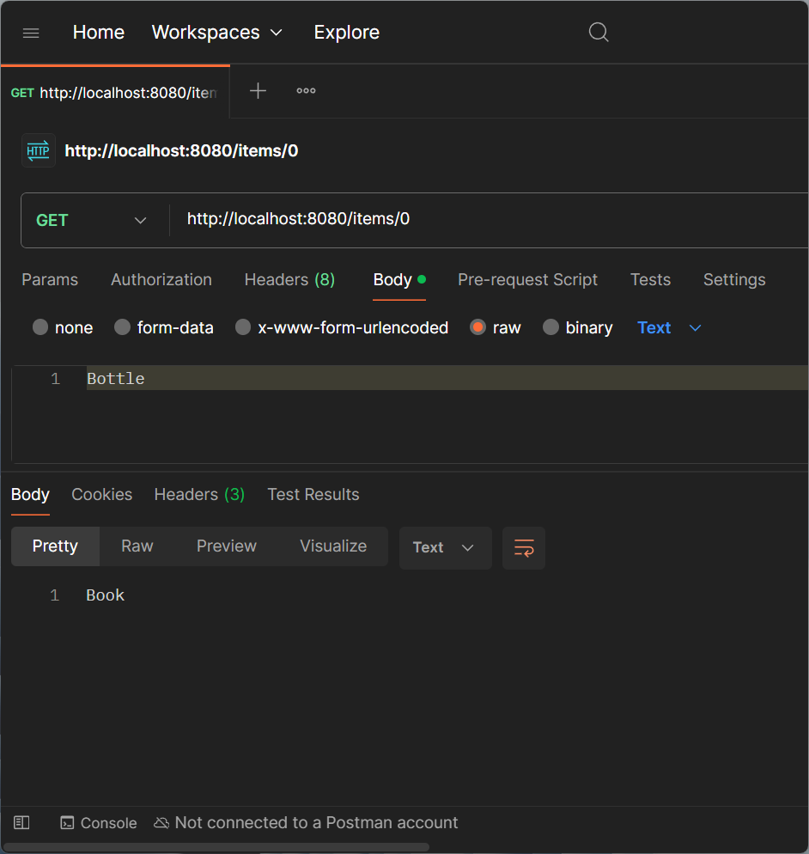

GET
http://localhost:8080/orders
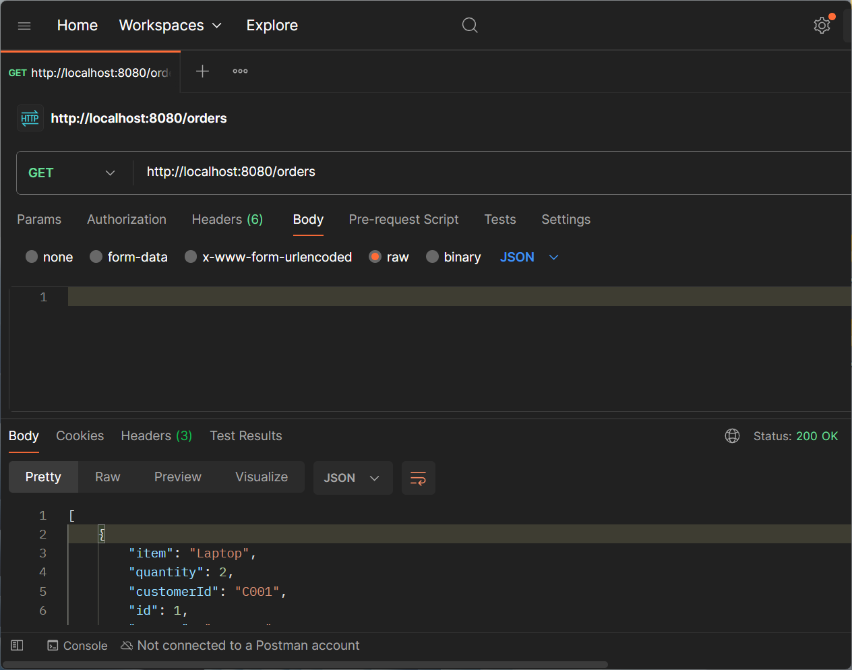

POST
http://localhost:8080/orders
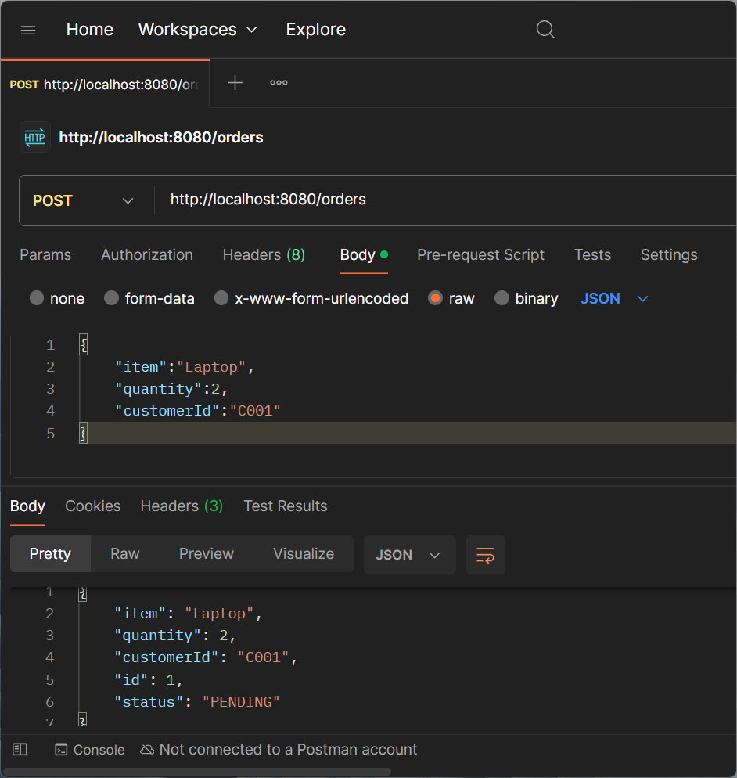

GET
http://localhost:8080/orders/1
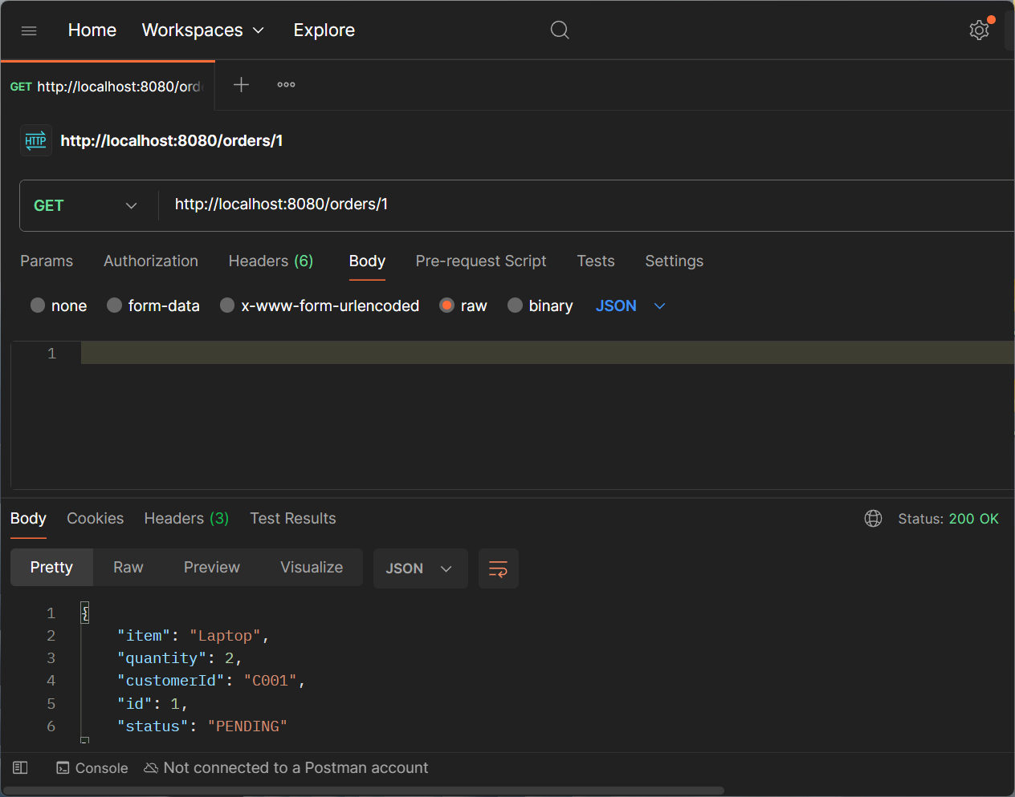

GET
http://localhost:8080/payments
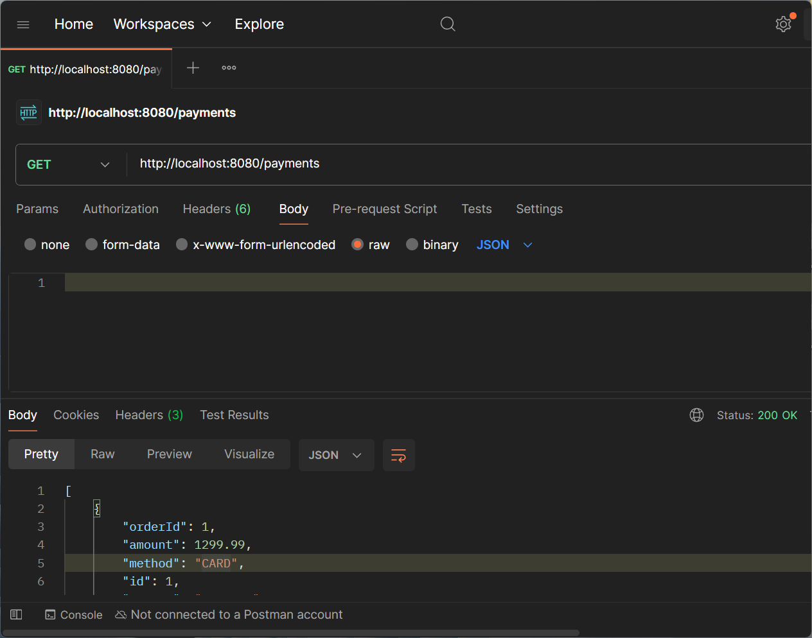

POST
http://localhost:8080/payments/process
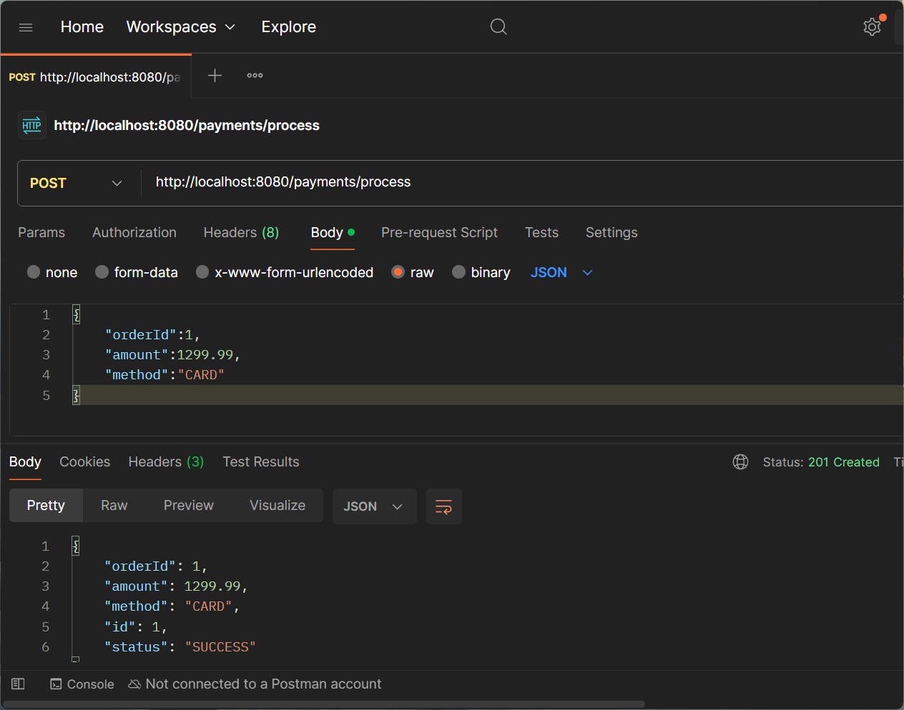

GET
http://localhost:8080/payments/1
